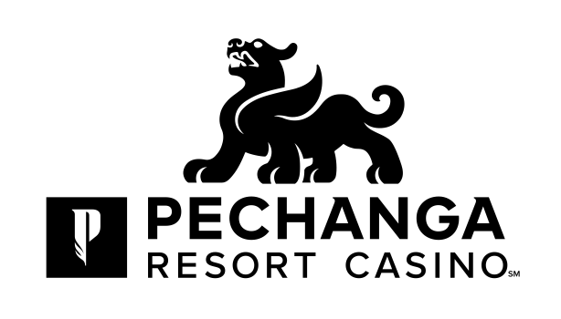

March 8, 2018

Dear Asian Media Guest,

Welcome! On behalf of Pechanga Resort Casino, we would like to welcome you to our Asian Media Day. You are some of the first guests to experience the full spectrum of our just-completed $300 million expansion and we are honored and proud you are our guests today.

What you will find with our expansion is our commitment to enhancing the appeal to every one of your senses that has made Pechanga the unsurpassed standard for hospitality, comfort and luxury among California resort casinos. Our just-completed expansion doubled our hotel rooms and suites to nearly 1,100, provided guests with an all new, standalone, luxurious day spa that encompasses 25,000-sq. feet with 17 treatment rooms and full hair/nail salon, created a 4.5-acre tropical pool paradise with multiple pools and cabanas – “The Cove” – introduced two new restaurants and added another 70,000 square feet of indoor meeting/event/concert space that has already played host to A-list acts such as Adam Sandler and Grasshopper.

Our improvements have taken to another level what is already the largest resort/casino in California and continued the dedication to our guests that brought us the coveted AAA Four Diamond award for hospitality excellence. Set amid rolling hills in the Temecula Wine Country, Pechanga offers its guests a casino floor larger than any in Las Vegas, one that features more than 4,500 state-of-the-art slots and video poker, 154 table games, a High Limit Salon, a spacious and stylish Poker Room with an Off-Track Betting facility and a Bingo Parlor of unparalleled comfort.

Our resort also features a picturesque championship golf course – Journey at Pechanga, 13 award-winning dining options for every palate and taste, A-list entertainment in the Pechanga Theater, up-and-coming comedians in the Pechanga Comedy Club and our Eagle’s Nest nightclub.

Along with experiencing all that Pechanga has to offer, we would like you to take special note of the new Pechanga Asian logo. As the property has grown and matured, so has our Asian brand, and the evolution of our logo reflects the continued, positive development of Pechanga Resort Casino.

We invite you to experience many of the amenities that set Pechanga on another level and enjoy much luck and good fortune on your visit.

With warmest regards,

Lee Torres
General Manager, Pechanga Resort & Casino

