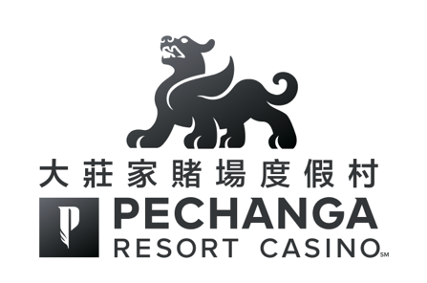

2018年3月 8日

尊敬的各位亞洲媒體嘉賓：

大家好！歡迎蒞臨「大莊家賭場度假村」！我謹此代表「大莊家」全體仝仁歡迎您們參加我們的亞洲媒體招待日之活動。「大莊家」感到莫大的榮幸及喜悅您們能夠出席今天我們斥資三億元之度假村新落成的酒店大樓並成為優先參觀的第一批團體及嘉賓之一 。

在擴建後的「大莊家」，您將能體驗我們致力為迎合大家的各種不同感官的需求而提升質素，使「大莊家」 成為具有最佳優質、貼心 、舒適及豪華的服務水準，非其他加州賭場度假村可媲美。我們全新完成的擴建工程把酒店客房及套房數目雙倍增加至近1,100間，並新建一座複式獨立兩層高 25,000平方呎的豪華日間水療護理中心，擁有17間水療護理室及美甲／美髮護髮廊。此外，還有佔地4.5英畝的綜合性游泳池項目包括水上樂園及池畔涼亭—「The Cove」， 以及兩家新增的星級餐飲食府。與此同時，擴建工程更為「大莊家」增添了70,000平方呎的豪華室內會議／活動／音樂會的場館，世界頂尖的歌手亞當·桑德勒（Adam Sandler）及香港著名草蜢樂隊（Grasshopper）均在這個全新的會展中心舉行演唱會。

擴建工程為原本已是加州最大規模的博彩娛樂及度假村的「大莊家」帶來更新領域層次並將繼續全面提升，我們一直致力為大家營造無與倫比的輕鬆悠閒度假環境，這讓我們持續榮獲美國汽車協會（AAA）評選為四鑽級的酒店。座落於南加州特曼庫拉酒鄉風景秀麗的山脈之間，「大莊家」的博彩娛樂廳的規模已超越拉斯維加斯，我們擁有4,500部全城最熱的角子機及視頻撲克，154台賭桌娛樂，一間高限注博彩廳，一間豪華寬敞的撲克廳並設有場外投注的設施，以及一間現代時尚的賓果遊戲中心。

除此以外，「大莊家」精彩玩樂層出不窮，更設有讓大家能一展身手，並且風景如畫具世界錦標賽級的 「Journey at Pechanga」高爾夫球場；13家星級食府供應各種美食；「大莊家劇場」勁爆震撼的娛樂表演；「大莊家Comedy Club喜劇會」讓您觀看欣賞各個不同歡聲笑語的喜劇；以及醉人美景的「Eagle’s Nest」夜總會均在「大莊家」一應俱全。

在您體驗「大莊家」休閒娛樂項目的同時，我們希望您能夠特別留意一下我們「大莊家」的全新亞洲品牌標誌。我們的亞洲品牌形象與博彩娛樂場及度假村一起繼續成長及逐漸成熟 。因此，我們更新的品牌標誌正反映「大莊家賭場度假村」時刻不斷進步，積極推動及追求臻善臻美的品質 。

我們在此誠意邀請您親身感受「大莊家」各項星級的娛樂設施，尊享各種精彩玩樂，輕鬆悠閒及專屬娛樂的嶄新體驗。

此致
敬禮！

「大莊家賭場度假村」總經理
Lee Torres

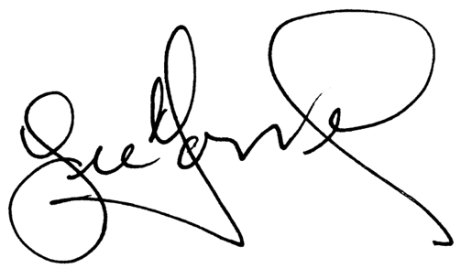

March 8, 2018

Dear Asian Media Guest,

Welcome! On behalf of Pechanga Resort Casino, we would like to welcome you to our Asian Media Day. You are some of the first guests to experience the full spectrum of our just-completed $300 million expansion and we are honored and proud you are our guests today.

What you will find with our expansion is our commitment to enhancing the appeal to every one of your senses that has made Pechanga the unsurpassed standard for hospitality, comfort and luxury among California resort casinos. Our just-completed expansion doubled our hotel rooms and suites to nearly 1,100, provided guests with an all new, standalone, luxurious day spa that encompasses 25,000-sq. feet with 17 treatment rooms and full hair/nail salon, created a 4.5-acre tropical pool paradise with multiple pools and cabanas – “The Cove” – introduced two new restaurants and added another 70,000 square feet of indoor meeting/event/concert space that has already played host to A-list acts such as Adam Sandler and Grasshopper.

Our improvements have taken to another level what is already the largest resort/casino in California and continued the dedication to our guests that brought us the coveted AAA Four Diamond award for hospitality excellence. Set amid rolling hills in the Temecula Wine Country, Pechanga offers its guests a casino floor larger than any in Las Vegas, one that features more than 4,500 state-of-the-art slots and video poker, 154 table games, a High Limit Salon, a spacious and stylish Poker Room with an Off-Track Betting facility and a Bingo Parlor of unparalleled comfort.

Our resort also features a picturesque championship golf course – Journey at Pechanga, 13 award-winning dining options for every palate and taste, A-list entertainment in the Pechanga Theater, up-and-coming comedians in the Pechanga Comedy Club and our Eagle’s Nest nightclub.

Along with experiencing all that Pechanga has to offer, we would like you to take special note of the new Pechanga Asian logo. As the property has grown and matured, so has our Asian brand, and the evolution of our logo reflects the continued, positive development of Pechanga Resort Casino.

We invite you to experience many of the amenities that set Pechanga on another level and enjoy much luck and good fortune on your visit.

With warmest regards,

Lee Torres
General Manager, Pechanga Resort & Casino

