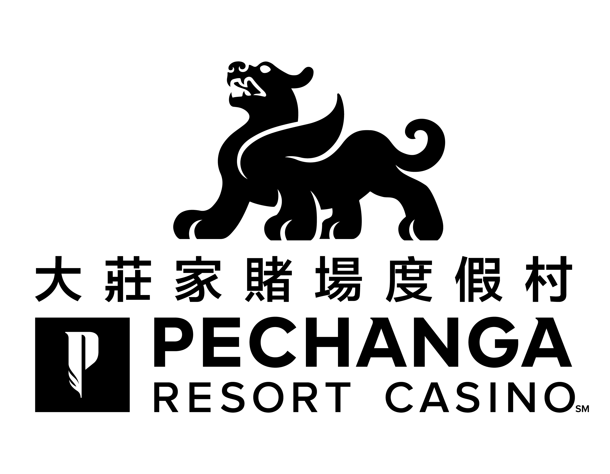
「大莊家賭場度假村」斥資三億元的擴建工程新翼經已落成
隆重舉行盛大的開幕歡慶週
體驗星級娛樂，享受尊貴禮遇
期待已久的「大莊家賭場度假村」擴建工程新增設項目經已落成，迎來歷史性的開幕慶典，為隆重其事，特別舉行盛大的開幕歡慶週。斥資三億元的「大莊家」新翼媲美加州及內華達州的任何一間博彩娛樂場。2018年3月8日(星期四) ，「大莊家」誠邀各界亞洲媒體機構蒞臨參加亞洲媒體招待日，優先參觀新酒店大樓及各項全新設施，是次活動將會是開幕歡慶週的一項盛事。「大莊家」總經理 Lee Torres 先生說： 「我們繼續致力使『大莊家賭場度假村』成為最佳優質與豪華的酒店住宿，以及更具娛樂性的世界級玩樂休閒度假勝地。」
是次活動並慶祝及答謝為特曼庫拉區帶來$5.5億元經濟增長及發展所作出的巨大貢獻，對度假村持續增長的亞裔客人們，更隆重推出了全新的「大莊家」亞洲品牌標誌。「大莊家」首席營銷總監 Bill Anderson 先生表示：「我們以最真誠的心及非常重視每一位亞裔客人，並更新了「大莊家」的亞洲品牌標誌，使其更能緊貼時代的潮流。」 「大莊家」全新亞洲品牌標誌從以往年輕活力的小獅子形象演變為我們現在所看到的成熟友善而振翅欲飛的雄獅。新"貔貅"商標寓意為亞裔客人帶來富貴，有祝君好運的寓意。此全新的亞洲品牌標誌讓「大莊家」這六年來在亞裔社區、本地及更遠的地方奠定了最頂尖的地位。
魯瑟諾族印第安人中的Pechanga分支部族首領及多位要員於2015年12月為擴建工程舉行了動工儀式，而工程第一期新增的東翼停車場於一年後完成啟用。而新建的酒店大樓擁有現代化設施的客房及豪華套房，透過豪華落地玻璃窗戶更可一覽四周風景怡人的特曼庫拉山谷、青山綠水間的Journey高爾夫球場及特曼庫拉城市風光。一座全新的複式獨立兩層高的豪華水療護理中心，擁有17間水療護理室、桑拿室、兩個水療按摩池、一個戶外泳池及池畔涼亭，以及招待男、女賓的美甲／美髮護髮廊。佔地4.5英畝的綜合性游泳池項目包括水上樂園及即將於春季開業名為「The Cove」池畔酒吧並以嶄新的「Coveside」時尚燒烤餐廳呈現，提供豐富多樣的餐飲美食，讓客人可在泳池邊或室內餐桌淺嚐細享或盡情大快朵頤。
新加入「大莊家」星級廚師團隊的實力名廚Jose Mendoza，為全新的「Lobby」燒烤酒吧帶來多款極具特色的美食。榮獲美國汽車協會（AAA）評級為四鑽級的「The Great Oak」牛排屋，為食客特設品種最齊全的美酒餐單及尊尚的美食餐饗體驗。「大莊家」擁有各具特色的亞洲風味餐廳是最吸引亞洲客人的原因之一。屢獲殊榮的星級餐飲食府包括「Bamboo」餐廳、「Umi」日式壽司吧、「Blazing Noodles」餐廳及「大莊家」自助餐廳，定能滿足每位喜愛品嘗不同口味的食客。「大莊家」並確保每家餐廳均為食客提供星級餐饗體驗及最正宗的亞洲地道風味的美食。
令人目不睱給的國際知名亞洲巨星在「大莊家」的現場表演亦是最吸引華語客人之處。在「大莊家」三億元的擴建新項目中，為大家提供一個星級娛樂新體驗，總面積達40,000平方呎的「大莊家」會展中心(Pechanga Summit) 可舉辦各類公司團體活動、舞台表演及競技賽事如MMA 綜合格鬥技等。「大莊家」會展中心(Pechanga Summit)首場亞洲演唱會更請來重量級香港著名組合「草蜢」蒞臨表演。演唱會當晚「草蜢」熱力四射載歌載舞的演出令現場氣氛升溫及獲得觀眾熱烈歡呼。此外，即將到來演出的台灣著名實力派女歌手黃小琥及嘉賓「天后」原唱者陳勢安，將於2018年3月31日（星期六）在「大莊家劇場」舉行演唱會。「大莊家劇場」可容納1,200個座位，曾在此表演的著名歌手包括亞洲樂壇天后張惠妹、香港著名歌星蘇永康、韓國著名唱作人朴軫永及黄致列等。
「大莊家」的華語專屬客戶服務團隊讓您更體驗VIP貴賓式禮遇。我們的華語專屬客戶服務團隊包括譚麗儀 （Erin Tan Mislang）、葉梅英 (Amy Rowe)、 管庭 (Doris Kuan)、及 唐景德 (Gabriel Tang) 。「大莊家」十六年來的卓越客戶服務，擁有四鑽級豪華酒店，以及世界級博彩玩樂均一應俱全。快來「大莊家」親身體驗星級娛樂，享受尊貴禮遇。
「大莊家賭場度假村」匯集精彩多姿的娛樂
「大莊家賭場渡假村」為美國其中之一間最大規模及提供最尊貴的賭場渡假體驗。榮獲USA Today 讀者票選為全美最佳賭場第一名。並自2002年起一直被AAA評為四鑽級酒店，無論是日間玩樂還是豪華住宿，「大莊家賭場度假村」總會帶給您無與倫比的悠閒度假環境，擁有超過4,500多部角子老虎機，賭桌娛樂，頂級娛樂節目，1,090間豪華酒店客房，星級餐飲食府，讓您煥發身心的水療護理，以及世界錦標賽級的Journey高爾夫球場。「大莊家賭場度假村」致力滿足客人及社區的需求，並與時俱進超越期許。魯瑟諾印第安人中的Pechanga族人擁有並經營「大莊家賭場度假村」。更多詳情，請致電免費專線1-888-PECHANGA，或瀏覽www.pechanga.com。點擊喜歡大莊家賭場渡假facebook網頁( Facebook.com/Pechanga) ，以及Twitter@PechangaCasino。必須年滿21歲或以上方可參與博彩活動。

$300 Million Dollar Expansion,
Pechanga Resort & Casino Celebrates Grand Opening Week
Brand New Facilities, Same World-Class Gaming
With much anticipation, Pechanga Resort & Casino celebrates a historical grand opening week. The $300 million spent on the resort expansion would rival any casino in California or Nevada. Thursday, March 8, 2018, Pechanga rolls out the red carpet for Asian Media Day, an exclusive event for many of the Asian media outlets, presenting sneak previews and exclusive tours of the new facilities. This event is certainly a highlight of the festivities during grand opening week. “We are completely committed to making Pechanga Resort & Casino a better, more luxurious and fun world-class gaming resort destination,” says Lee Torres, general manager at Pechanga.

This occasion celebrates and acknowledges the great impact of the Asian community to the $550 million-dollar economic growth and development of Temecula Valley. A new redesign of brand and logo was launched for our
ever-growing Asian clientele. “We take the loyalty from our Asian guests very seriously and with Pechanga’s newly designed logo and branding, it was of utmost importance to bring Pechanga into present day.” says Bill Anderson, chief marketing officer at Pechanga. The logo evolved from the youthful lion to the majestic and matured winged lion that we see today at Pechanga. The logo Pi Xiu symbolizes wealth and good fortune. The redesign of the new logo reflects the triumphant six years Pechanga had established itself as a first-class destination for Asians, local and afar.

Dignitaries and tribal leaders from the Pechanga Band of Luiseño broke ground in December 2015 and completed its first phase, the new East Parking Garage, one year later. The new resort tower offers modern guest rooms and lavish suites with floor-to-ceiling views of the surrounding south Temecula Mountains, the Journey golf course and the Temecula cityscape. The brand new, luxury two-story spa and resort features 17 therapy rooms, sauna, two hydrotherapy pools, an outdoor pool and cabanas, and a full-service salon for men and women. The 4.5-acre resort style pool complex, waterslides, and swim-up bar called The Cove will be unveiled this spring along with the new Coveside Grill restaurant, offering a variety of delicious bites served poolside or table-side.

Among the many master chefs at Pechanga, chef Jose Mendoza joins the team and brings a variety of culinary flavors to the new Lobby Bar & Grill. The Great Oak Steakhouse, awarded AAA Four Diamond features an exceptional wine list and a true fine dining experience. The extensive selections of Asian restaurants are the reason Pechanga is the most Asian friendly destination. Restaurants such as Bamboo, Umi, Blazing Noodles, and Pechanga’s international buffet will sure to delight any culinary adventurer. Pechanga acknowledges the discerning taste of the Asian community and assures every restaurant at Pechanga offers top-rated, award-winning service, with regional flavors to match.
The countless international acts and high-profile Asian celebrities are the reason Pechanga is the most Asian friendly destination. As part of the $300 million expansion, Pechanga wants to bring your entertainment experience to the next level. The 40,000 square feet, Pechanga Summit truly impresses and accommodates everything from corporate events, stage performances, and arena sports such as MMA fights. The Pechanga Summit presented its first Asian concert featuring the dynamic Hong Kong trio,“The Grasshoppers.” Their popular music and dynamic stage performances had guests dancing in the aisle and into the night. Upcoming concerts include Taiwanese star Tiger Huang and Andrew Tan on
Saturday, March 31, 2018 at the Pechanga Theater, a 1,200-seat showroom where previous acts such as A-Mei, William So, JYP, and Hwang Chi Yeo also graced the stage.

The exceptional team at Pechanga brings a wealth of experience and extends their first-rate services for their valued clients. The team of Chinese speaking hosts includes Erin Tan Mislang, Amy Rowe, Doris Kuan, and Gabriel Tang. Sixteen years of outstanding services, four diamond accommodations, and world-class gaming. Discover the difference and see what makes Pechanga Resort & Casino the most global Asian-friendly destination for world-class gaming and premium entertainment.

About Pechanga Resort & Casino
Pechanga Resort & Casino offers one of the largest and most expansive resort/casino experiences anywhere in the United States. Voted the Number One casino in America by readers of USA TODAY and rated a Four Diamond property by AAA since 2002, Pechanga Resort & Casino provides an unparalleled getaway. Offering more than 4,500 of the hottest slots, table games, world-class entertainment, 1,090 hotel rooms, dining, spa and championship golf at Journey at Pechanga, Pechanga Resort & Casino features a destination that meets and exceeds the needs of its guests and the community. Pechanga Resort & Casino is owned and operated by the Pechanga Band of Luiseño Indians. For more information, call toll free 1-888-PECHANGA or visit www.Pechanga.com. Follow Pechanga Resort & Casino on Facebook and on Twitter @PechangaCasino. Pechanga Resort & Casino is open 24-hours. Guests must be 21 and older to enter the casino.

